My application is configured to run on GlassFish 4.1.1 or latest.

I have made use of the Java Derby database.

Please create the application database CurrencyDB as follows:-

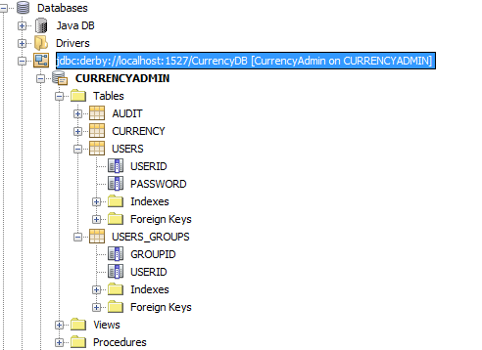

With a username and password of CurrencyDB.

Please configure the security realm (jdbcRealm) as follows:-

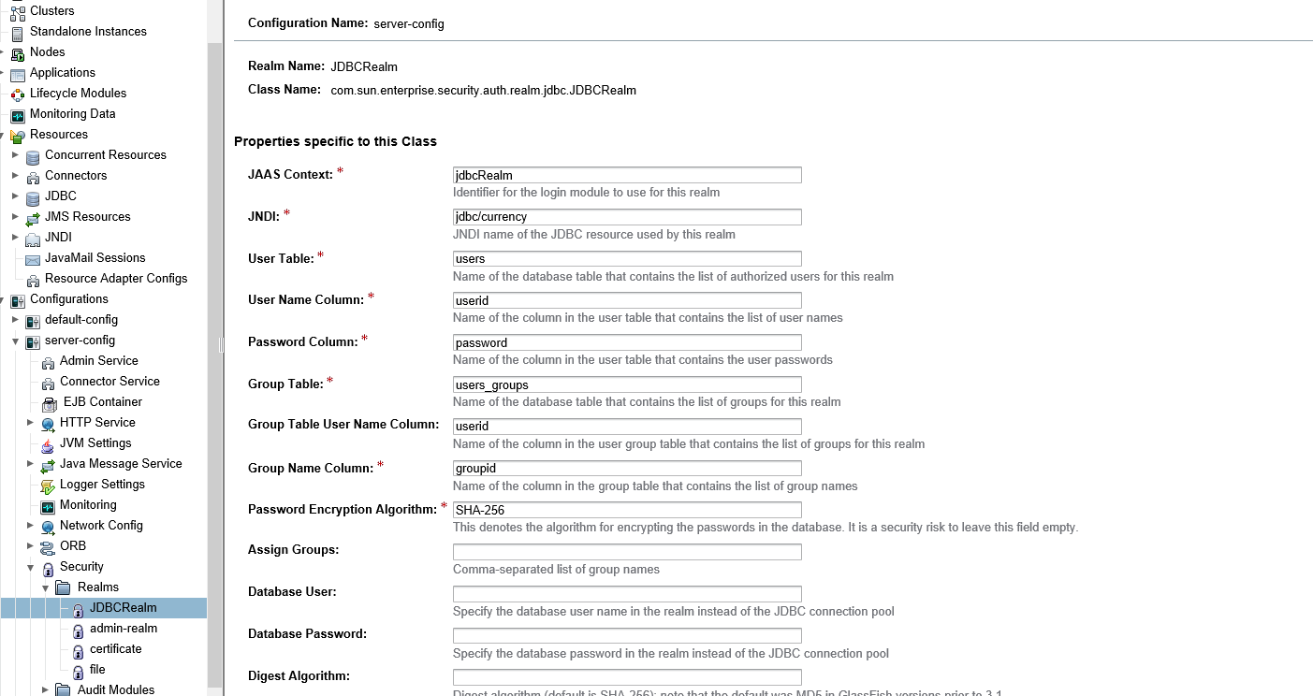

Please use the attached password generator in project Password Generator that makes use of the SHA-256 encryption algorithm.

Add a userid record in the User table together with the generated password.

Add the same userid and associated “admin” role in the users_groups table.

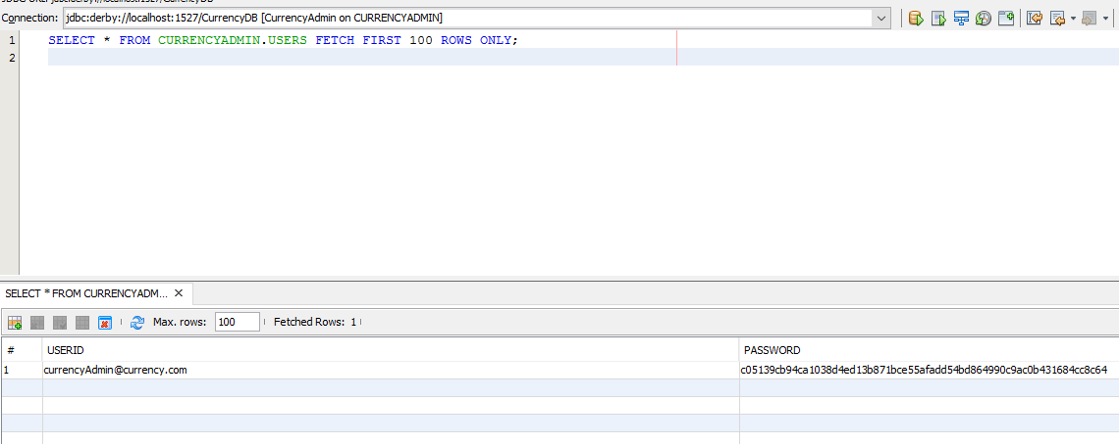

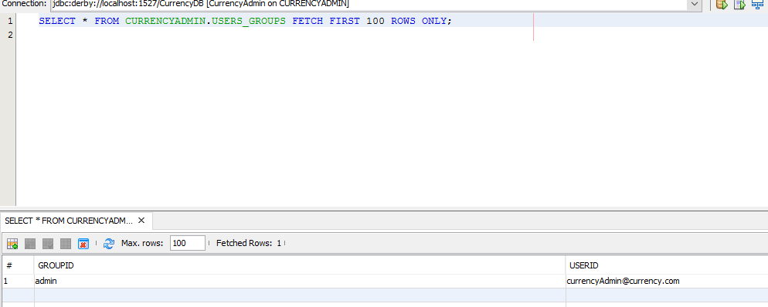

Couldn't get the Restful requirement working.

If I had more time, I would have included a module that would connect to external systems that offer regular updates to live currency rates through web services.

I would have implemented a sign up feature.